Abstract template for REST in Paris
Surname 1, Name 1¹; Surname 2, Name 2^{1,2}
¹Physics Department, My University, MyCity, Address, COUNTRY
Email:jdoe@mxu.edu,Web site: http://www.myuni.edu/myself.html
²Physics Department 2, My University 2, MyCity 2, Address 2, COUNTRY 2

Please, complete the present template according to guidelines given below and saving the abstract document as “Surname_Abstract REST_Kind.docx”, where Surname should be replaced by the surname of the presenter and Kind should be replaced by Oral or Poster according to your preference.
The abstract should be in the format of Microsoft Word document (.doc or .docx extensions). Each abstract should not exceed one page. Please be sure that the presenting author is underlined and designated with detailed contact information, including his/her email address and web page. Use Times New Roman fonts of size pt14 (Title), pt12 (authors), pt 11 (body), pt10 (affiliations, references, figure caption). A figure with a caption can also be included and the list of references should be given at the end including a link with the article doi identifier.
Submission of abstracts should be made by sending an email to restinparis@gmail.com before November 1st.

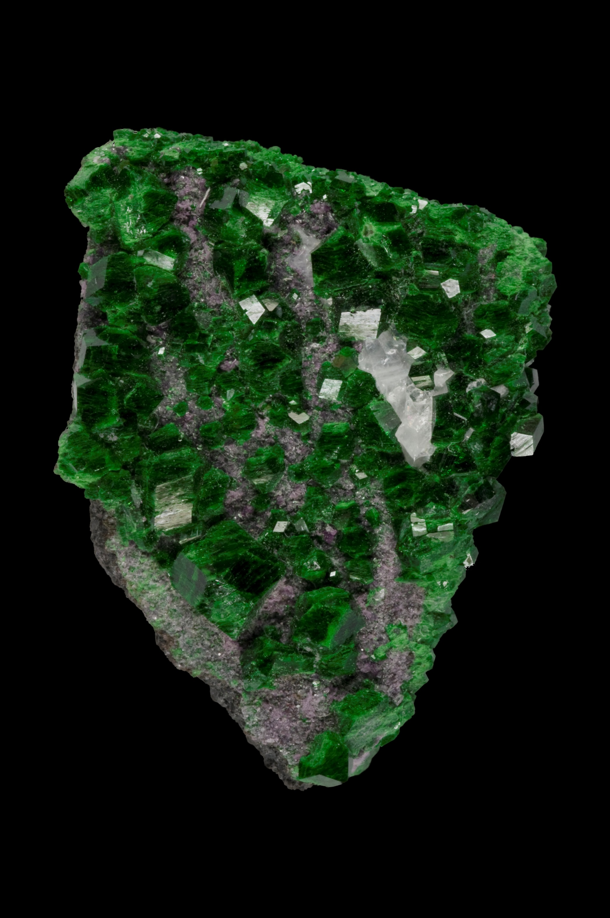
Fig.1: Uvarovite crystal from the mineral collection of IMPMC/UPMC.

References
[1] A. Surname1, B. Surname2 and C. Surname3, Journal title Volume, page (year) link.

